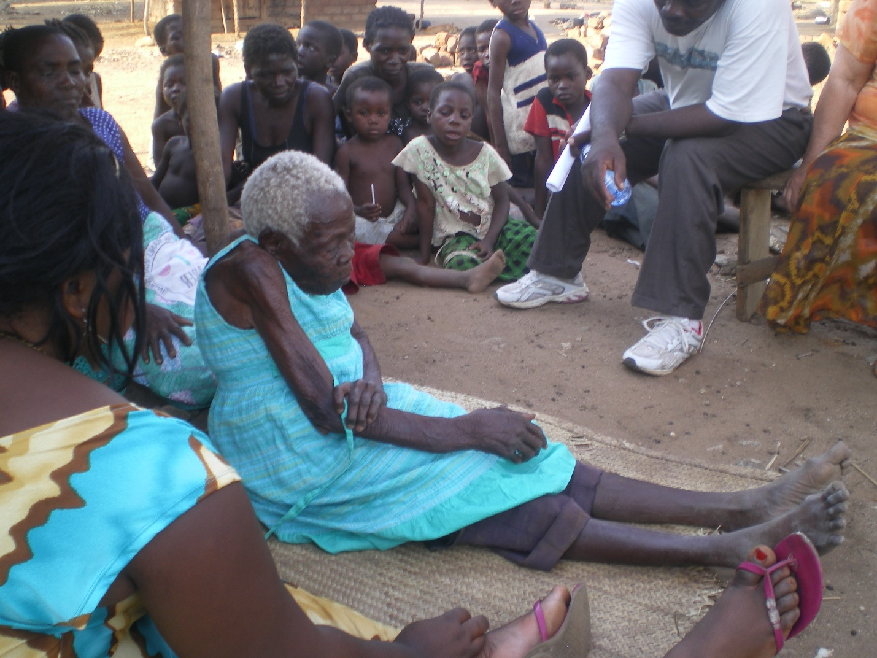

106 years old. She had broken her arm. You can see the break in the photo. She refused to go to the hospital saying that her children had all gone there and died there. We prayed for healing. Hers was the first new house that we built.

